Name _________________________________
Unit 4A Test (Week 19.5) – Organizing and Recognizing Data
Use the tally chart to answer the questions.
Favorite Place
Place | Tally | Total
Circus
Zoo
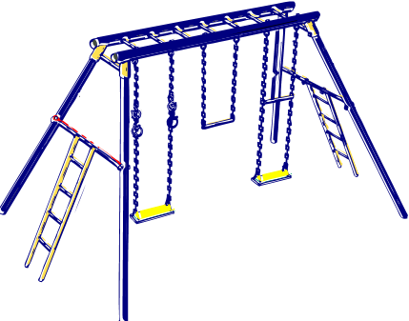Playground

- How many people chose the circus? __________ people
- How many more people chose the zoo than the playground? __________ people
- How many people took the survey? __________people
- Which place got the most votes? ________________

- Why do you think this place got the most votes?
____________________________________________________________________________________________________________________________________
Circus
Zoo
Playground
- Use the tally chart to make a bar graph. Color in the bar graph to show how many voted for each place.

- What are 3 more favorite places you could collect data on?
____________________________________________________________________________________________________________________________________

