Smarter Balanced Performance Task
7th Grade Math

Essential Standard: “I can solve linear equations with one or more steps.”

- Task Overview
- Classroom Activity
- Student Task: Parts 1 and 2
- Task Specifications and Scoring Rubrics
Task Overview (20 minutes for classroom activity, 35 for performance task = 55 total minutes)
Classroom Activity (20 minutes)
Students will be introduced to the topic expanding linear equations by working with an area model. They will design a garden and conclude their work by explaining how their model alludes to solving a linear equation.
Part 1: Students will design a model and answer three constructed response questions derived from their model.
Part 2: Students will justify how their model represents their equation and clarify how their model shows the distributive property.
Scoring Rubric: Students responses at the end of part 1 and the explanation in part 2 will be scored.

Garden of Learning
Students in Mr. Walsh’s math class want to begin a garden outside his classroom window. The garden that they want to produce will include trees and flowers. Below is a layout of the available space they have to use.

width

length

The length of the garden is 12 yards. The width however is comprised of a 2 yard width for planting rows of flower shrubs, as well as an unknown length for planting the trees. On the above diagram, separate the planting space as described.
- Each square yard will allow for one flower shrub. Based off your picture, how many flower shrubs can be planted?

- Write an expression that will represent the entire area of the garden.

The type of tree you plant in the garden can vary in size, which is why the width of this section is unknown. Below is a list of trees and flowers that are available to be planted.
Type of Tree | Cost | Size | Type of Flower Shrub | Cost
Blue Spruce  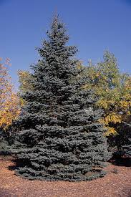 | $16 | 3x3 | Rose Bush  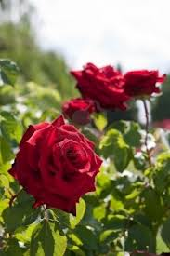 | $9
Maple  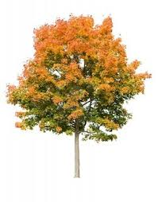 | $12 | 2x2 | Sunflower  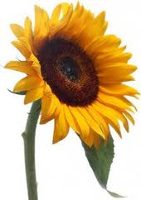 | $5
Apple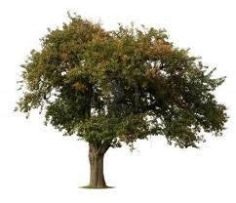 | $20 | 2.5x2.5 | Daisies  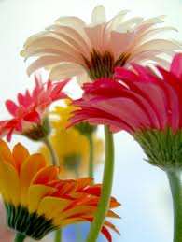 | $4

- The class before you planned their garden out to have an area of 60 square yards. Based off of this information, determine which tree they chose and explain how you concluded that.

- The class has been given a budget of $280. You must choose some combination of tree and flower to plant in the garden. The school’s groundkeeper has limited the area of the garden to only 54 square yards. Come up with a possible combination of flowers and trees that can be planted given the restrictions. Then draw your garden below.

