Insects vs. Humans

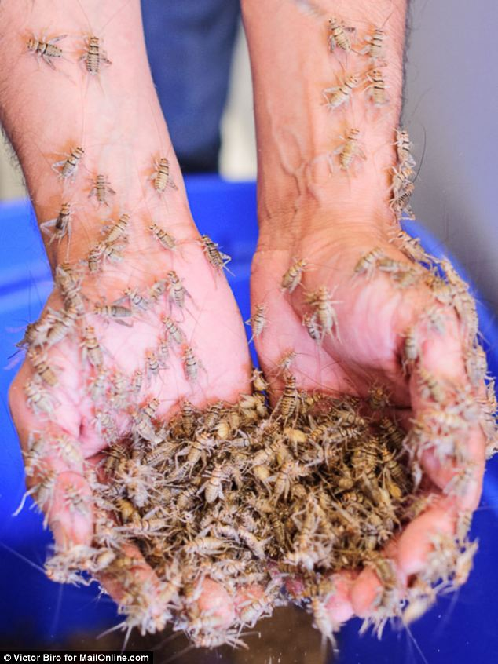
There are a lot of people on Planet Earth (How many?). But something we don’t think about very often is how many insects there are. Not how many are in your house or in the anthill behind your house, but in total. We keep track of how many people are in the United States, or in China, or in India, but we never keep track of how many insects there are.

So what do you think? Just predict based on what you know, don’t worry about numbers. Think to yourself for a few minutes and then share with your group. Talk about these questions with your group:

- Are there more people or more insects on earth?
- Whichever you think there are more of, are there many more, or a few more of them? Why do you think that?

Product 1: Write a short note to your teacher explaining what you were thinking about in Questions 1 and 2. Be sure to explain your reasoning clearly and use specific descriptive words.

So here is the Central Question for this situation:

Which weigh more: all the humans on Earth or all the insects on Earth?

This is a big question. You thought about part of this in the opening discussion, but not the whole question. So think about the following for a couple of minutes and talk with your group:

- Is there one correct answer to this question or more than one?
- Is it possible to find the exact answer? Why do you think that?
- What kinds of numbers might you encounter in your work?
- How do we express big numbers in a shorter format?
- What do you remember about scientific notation?

In order to answer this question there are some important things to think about.

- Talk with your group about the questions that might be important to think about or that you might have to answer to get an answer to the Central Question.

Product 2: Decide with your group on two questions that you think must be answered in order to get to an answer to the Central Question. Write them on the Poster Paper and explain to the class why you think they have to be answered.

Now that you’ve talked about some questions and some ideas with your classmates, it is time to explore some resources on your own. Below you will find several web sources that may help you think about and possibly answer the Central Question. Review the resources before you begin calculating!!

Population clock: http://www.census.gov/popclock/
Wikipedia population search: http://en.wikipedia.org/wiki/World_population
Bug Info page: http://www.si.edu/Encyclopedia_SI/nmnh/buginfo/bugnos.htm
Bug News: http://ucanr.edu/blogs/blogcore/postdetail.cfm?postnum=877
How Stuff Works: http://animals.howstuffworks.com/animal-facts/insects-on-earth1.htm

Now that you’ve looked through the sources, it’s important to point out key information.

Product 3: Write a 5 paragraph essay that summarizes what your readings had to say about insects and humans, including specific numbers. Be sure to tell where you got each piece of information (cite your sources). If there are conflicting sources, make sure you identify the pieces of data, tell which one you chose to believe, and justify your choice.

Okay, it’s time to try to find an answer! Gather all of your data (numbers, units, labels, etc.), decide how to display your numbers, and do any calculations you need.

Here are some assumptions that might be helpful:
- The average weight of an insect (like an ant) is 2 to 6 milligrams (mg).
- The average weight of a human is 40 to 60 kilograms (kg).

Product 4: After you’ve found an answer, put your calculations together in a neat format on paper. Provide a detailed explanation of your calculations, both what you did and why you did it. Your explanation should be clear and in complete sentences. It should also be written for a classmate that was absent during your work time, so that he or she can easily understand what you did and why you did it.

Be prepared to discuss your results with the group.

