World Records in the One-mile Sprint

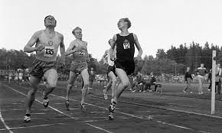
There are some FAST people in this world. Since the 1860’s the world has kept track of records in the one-mile run. In the 1930’s a mathematician predicted, based on a list of world records, when the world record would “break 4 minutes.” Using math modeling he predicted the exact year when the world record would fall below 4 minutes. Crazy right? Let’s see if we can do what he did.

Look at the data below. What you see is a list of record times in the one-mile sprint, along with the year and other information about the runners.

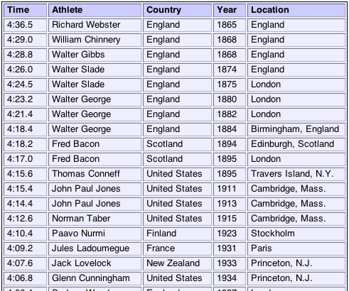
Figure 1: Men's World Record Times (http://www.maa.org/sites/default/files/images/upload_library/3/osslets/100multiParameterAnimation/mile_record_scatter.html)
So what do you think? Plan how you might use this data to predict the year the record drops below 4 minutes; don’t worry about numbers, just plan. Think to yourself for a few minutes and then share with your group. Talk about these questions with your group:

- How can you identify and analyze any patterns in the data?
- Are there representations of the data that might help you develop a model?

Product 1: Write a short note to your teacher explaining your plan. Be specific about the steps you’ll take, the representations you might use, and the model you want to get to.

Decide with your group on the plan you will use to develop your model, analyze its appropriateness, predict the year, and examine the reasonableness of your result.

Product 2: Prepare a short report (1-2 pages) detailing your process and results. Be sure to highlight your prediction and explain your calculations. Be sure to explain all the parameters of your model and their meaning in terms of the context.

Go to the following website to compare your results to reality: http://www.maa.org/sites/default/files/images/upload_library/3/osslets/100multiParameterAnimation/mile_record_scatter.html

Now that you’ve had some experience with modeling world records, let’s shift our attention a little bit.

Here is the Central Question for this situation:

When will the women’s world record in the one-mile run drop below 4 minutes?

While Wikipedia is not always a good source, some data can be reliable. The table below was taken from an entry that had excellent sources.

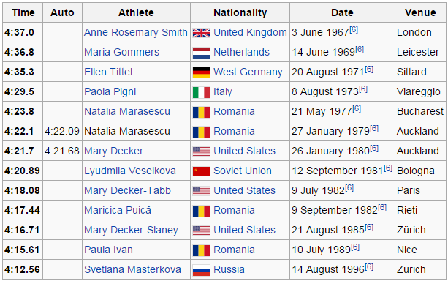
Figure 2: Women's World Record Times
(http://en.wikipedia.org/wiki/Mile_run_world_record_progression)

Product 3: As a group, create a mathematical model of the data in Figure 2. Represent the data in all the necessary ways. Choose your model wisely and justify your choice. Be prepared to defend your answer to the class. Display your findings and your prediction in a poster on chart paper. Do some research on the web to verify the accuracy of your prediction. Include this information in your poster.

You’ve now completed two mathematical models and used them to predict events in real life. Let’s take a look at both models together. As you compare the two models and the processes used to create them, think about the following questions:

- Is there a model that is more accurate than another?

