Performance Task: Maximizing the Volume of a Can
Jerry works at a canning company. His boss tells him that they want to use 24π in² of aluminum to construct cans for their product. His boss has tasked him with figuring out how to maximize the amount of volume each of these cans can hold. Assume that each can is approximately a cylinder.
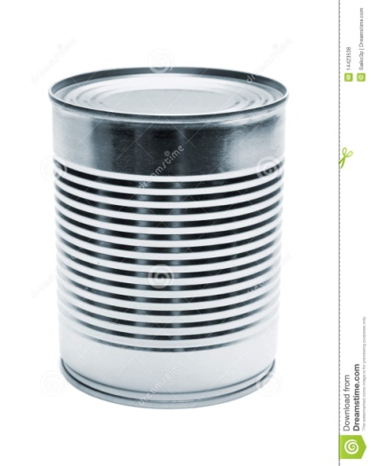
Part A
- Determine some different combinations of radii and heights that would produce a surface area of 24π in². Record these as ordered pairs, (r, h). Determine at least 6 different such pairs.

- Are there values for r and h in which it is impossible to have a surface area of 24π in²? If so, how big can they get? If not, explain why not.

Part B
- For each of the ordered pairs you determined in part A, calculate the volume of the can with these dimensions. Which one produces the largest volume?

- Based on your volume calculations, the maximum volume MUST fall between what two radius values? What are the corresponding height values?

- Write up a paragraph “report” to your boss demonstrating your findings. What would be your recommendation as a solution to this problem?
Performance Task Overview: Maximizing the Volume of a Can
TASK PERFORMANCE LEVELS:
Level 1: Demonstrates Minimal Success (0-7 points)
The student’s response shows few of the elements of performance that the tasks demand. The
work shows a minimal attempt on the problem and struggles to make a coherent attack on the
problem. Communication is limited and shows minimal reasoning. The student’s response
rarely uses definitions in their explanations. The student struggles to recognize patterns or the
structure of the problem situation.

Level 2: Performance below Standard (8-15 points)
The student’s response shows some of the elements of performance that the tasks demand and
some signs of a coherent attack on the core of some of the problems. However, the
shortcomings are substantial and the evidence suggests that the student would not be able to
produce high-quality solutions without significant further instruction. The student might ignore
or fail to address some of the constraints. The student may occasionally make sense of
quantities in relationships in the problem, but their use of quantity is limited or not fully
developed. The student response may not state assumptions, definitions, and previously
established results. While the student makes an attack on the problem, it is incomplete. The
student may recognize some patterns or structures, but has trouble generalizing or using them
to solve the problem.

Level 3: Performance at Standard (16-22 points)
For most of the task, the student’s response shows the main elements of performance that the
tasks demand and is organized as a coherent attack on the core of the problem. There are
errors or omissions, some of which may be important, but of a kind that the student could well
fix, with more time for checking and revision and some limited help. The student explains the
problem and identifies constraints. The student makes sense of quantities and their
relationships in the problem situations. The student often uses abstractions to represent a
problem symbolically or with other mathematical representations. The student response may
use assumptions, definitions, and previously established results in constructing arguments. They
may make conjectures and build a logical progression of statements to explore the truth of their
conjectures. The student might discern patterns or structures and make connections between
representations.

Level 4: Achieves Standards at a High Level (23-30 points)
The student’s response meets the demands of nearly the entire task, with few errors. With
some more time for checking and revision, excellent solutions would seem likely. The student
response shows understanding and use of stated assumptions, definitions and previously
established results in construction arguments. The student is able to make conjectures and build
a logical progression of statements to explore the truth of their conjecture. The student
response routinely interprets their mathematical results in the context of the situation and
reflects on whether the results make sense. The communication is precise, using definitions
clearly. Students look closely to discern a pattern or structure. The body of work looks at the
overall situation of the problem and process, while attending to the details.

COMMON CORE STANDARDS ASSESSED:
A-REI.10, F-IF.5, G-GMD.3, G-MG.3

ANSWER KEY:
r | 0.5 | 1 | 1.5 | 2 | 2.5 | 3
h | 23.5 | 11 | 6.5 | 4 | 2.3 | 1
Part A (10 points)
- $24π=2πr^{2}+2πrh$

- If h = 0, then it will allow r to become as large as $\sqrt{12}≈3.46$ in. So, r cannot be 3.46 in or larger. There is no limit to how large h can be, since you can always make r smaller to compensate.

Part B (15 points)
r | 0.5 | 1 | 1.5 | 2 | 2.5 | 3
h | 23.5 | 11 | 6.5 | 4 | 2.3 | 1
V | 18.457 | 34.558 | 45.946 | 50.265 | 45.160 | 28.274

The combination of r = 2 in and h = 4 in produces the largest volume.

- The maximum volume must fall between r = 1.5 and r = 2.5 inches, since the volume could be slightly more in between 1.5 and 2 inches or in between 2 and 2.5 inches. The corresponding heights that it must fall within are h = 6.5 and h = 2.3 inches.

- Based on the findings of this investigation, we can know for sure that the maximum volume will be obtained if a can is constructed using a radius between 1.5 and 2.5 inches and a height between 6.5 and 2.3 inches. The best approximation we have based on the data is that a can constructed using a radius of 2 inches and height of 4 inches will produce a product that maximizes the volume.

RUBRIC:
Elements of the Task Include:  - Know and use the surface area formula for a cylinder to test various values of r and h to produce a surface area of 24π in².  - Understand the concept of domain as it applies to a context (for both height and radius).  - Know and use the volume formula for a cylinder to test various values of r and h to produce a maximum volume.  - Apply the Mean Value Theorem to produce a possible range of values that a solution could take on.  - Summarize and synthesize results and present them in a way that is easy to understand. | Points Earned
Part A (10 points)

5 points: Pick values of r and use them to determine what corresponding values of h are needed to produce a surface area of 24π in².

5 points: Continue to increase or decrease values of r to test when the surface area is impossible to obtain. Test values of h to determine how r must change to produce a surface area of 24π in².

Part B (15 points)

5 points: Use known values of r and h to produce corresponding volumes of the cylinder. Identify the largest volume.

5 points: Use the Mean Value Theorem to determine between what two values the maximum must fall OR use logic to consider possible circumstances that could put the maximum value in different places amongst the data. Align appropriate corresponding values for the height.

5 points: The results from the previous two questions are summarized in a concise and accurate.

