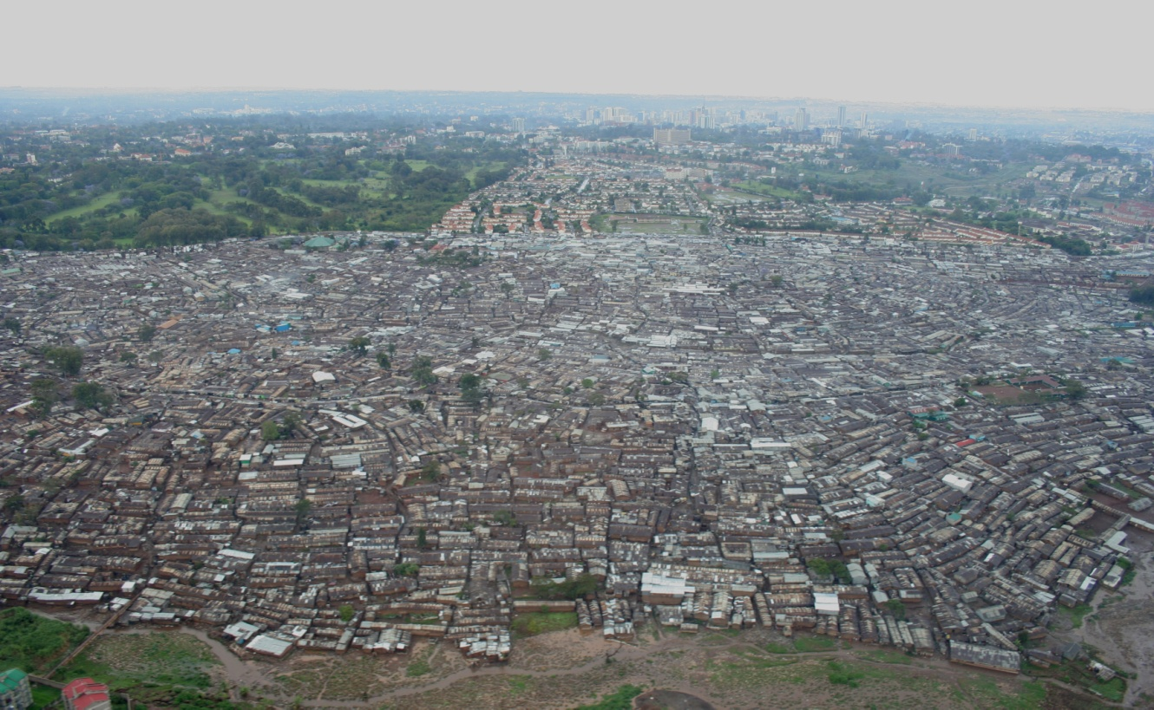
ECONOMICS Name: _____________________________
You are about to accomplish a Performance Task. This involves several sub-tasks. Follow directions.

1. Compare and Contrast. Look at the three pictures. They are of cities in the world. Write three paragraphs where the first begins, “I see…” the second starts as, “I think…” and the last is “I wonder…”.
(See attached rubric for Compare and Contrast.)

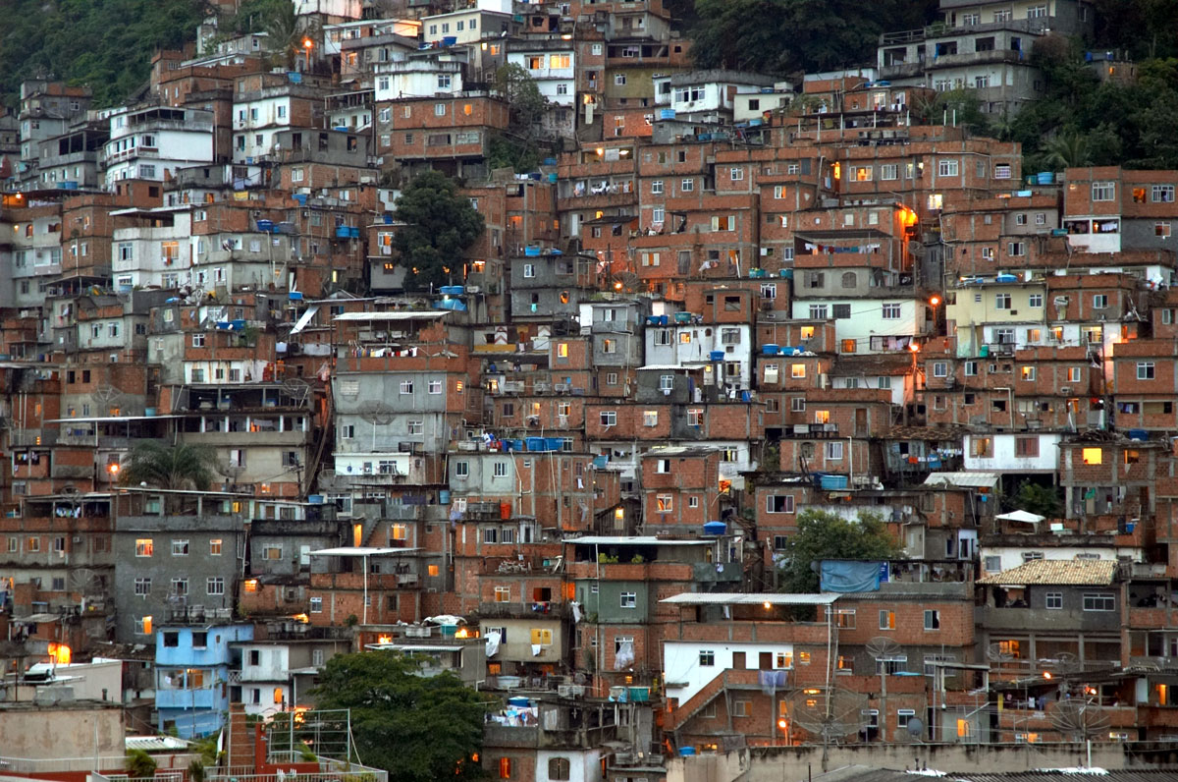
______________________________________________________________________________________________________________________________________________________________________________________________________________________________________________________________________________
______________________________________________________________________________________________________________________________________________________________________________________________________________________________________________________________________________
______________________________________________________________________________________________________________________________________________________________________________________________________________________________________________________________________________
______________________________________________________________________________________________________________________________________________________________________________________________________________________________________________________________________________
______________________________________________________________________________________________________________________________________________________________________________________________________________________________________________________________________________
______________________________________________________________________________________________________________________________________________________________________________________________________________________________________________________________________________
______________________________________________________________________________________________________________________________________________________________________________________________________________________________________________________________________________
______________________________________________________________________________________________________________________________________________________________________________________________________________________________________________________________________________
______________________________________________________________________________________________________________________________________________________________________________________________________________________________________________________________________________
______________________________________________________________________________________________________________________________________________________________________________________________________________________________________________________________________________
______________________________________________________________________________________________________________________________________________________________________________________________________________________________________________________________________________
______________________________________________________________________________________________________________________________________________________________________________________________________________________________________________________________________________
______________________________________________________________________________________________________________________________________________________________________________________________________________________________________________________________________________
______________________________________________________________________________________________________________________________________________________________________________________________________________________________________________________________________________
______________________________________________________________________________________________________________________________________________________________________________________________________________________________________________________________________________
______________________________________________________________________________________________________________________________________________________________________________________________________________________________________________________________________________
DO NOT READ BEYOND THIS POINT UNTIL FINISHED WITH THE FIRST TASK!!!

2. Internet Research. Look at the three pictures again. Know that the first picture is of Nairobi, Kenya, the second of New York City, and the last of a favela in Sao Paulo, Brazil. Research the following items of information, and record your findings, to include URLs of your sources. You might want to begin your research at http://www.heritage.org/index/, http://www.gapminder.org/world/, and https://www.cia.gov/library/publications/the-world-factbook/ but do not limit yourself to these sites, use more!
(See attached rubric for Internet Research.)

- The form of government, both national and local
- The level of corruption within that form of government (how closely they abide to The Rule of Law, Private Property Rights, and how much bureaucratic red tape involved to begin a business, purchase property, buy a business, etc.)
- The GDP of that country
- General level of infrastructure available to the citizen of each city
- The population of each city
- The geography of each city (hills/mountains, rivers, bays, close to trans-oceanic transport, etc.)

3. Create a matrix/grid of results from your Internet Research. For example…

CITY Gov’t Type Corruption GDP Infrastructure Population Geography

Nairobi

New York

Sao Paulo
You likely will require more space for you specific answers, but the above matrix example provides you with a template concept that you might use. Other formats that you find more useful are acceptable. Email your matrix to me as per policy.

4. Generate a Written Report of your findings, and include aspects of what you wrote for Compare and Contrast.
(See attached rubric for Written Report.)

Compare and Contrast rubric
16 possible points

Purpose & Supporting Details

4 The paper compares and contrasts items clearly. The paper points to specific examples to illustrate the comparison. The paper includes only the information relevant to the comparison.

3 The paper compares and contrasts items clearly, but the supporting information is general. The paper includes only the information relevant to the comparison.

2 The paper compares and contrasts items clearly, but the supporting information is incomplete. The paper may include information that is not relevant to the comparison.

1 The paper compares or contrasts, but does not include both. There is no supporting information or support is incomplete.

Organization & Structure

4 The paper breaks the information into whole-to-whole, similarities-to-differences, or point-by-point structure. It follows a consistent order when discussing the comparison.

3 The paper breaks the information into whole-to-whole, similarities-to-differences, or point-by-point structure but does not follow a consistent order when discussing the comparison.

2 The paper breaks the information into whole-to-whole, similarities-to-differences, or point-by-point structure, but some information is in the wrong section. Some details are not in a logical or expected order, and this distracts the reader. Many details are not in a logical or expected order.

1 There is little sense that the writing is organized.

Transitions

4 The paper moves smoothly from one idea to the next. The paper uses comparison and contrast transition words to show relationships between ideas.

3 The paper moves well from one idea to the next, but with occasional glitches. The paper uses a variety of sentence structures and transitions.

2 The paper moves from one idea to the next, but there is little variety. The paper uses comparison and contrast transition words to show relationships between ideas. Some transitions work well; but connections between other ideas are fuzzy.

1 The transitions between ideas are unclear or nonexistent.

Grammar & Spelling (Conventions)

4 Writer makes no errors in grammar or spelling that distract the reader from the content.

3 Writer makes 1-2 errors in grammar or spelling that distract the reader from the content.

2 Writer makes 3-4 errors in grammar or spelling that distract the reader from the content.

1 Writer makes more than 4 errors in grammar or spelling that distract the reader from the content.
Internet Research rubric
4 x 3 = 12 possible points
1 - Limited
• gathers information from one Internet site with teacher assistance
• with assistance distinguishes between some factual information and opinion
• there is evidence of difficulty in organizing the information gathered
• spelling, grammar, capitalization, and punctuation are inconsistent; errors may interfere with writer’s intended meaning
• does not accurately cite the source of the information
2 - Developing
• gathers information using one Internet site
• distinguishes between some factual information and opinion
• attempts to organize the information acquired
• some errors in spelling, grammar, capitalization, and punctuation do not detract from the meaning of the content
• makes mistakes in citing the information, making it difficult to locate the source
3 - Proficient
• gathers information from 3 or more Internet sites
• evaluates the relevance of information gathered
• distinguishes between factual information and opinion
• effectively organizes the information acquired
• spelling, grammar, capitalization, and punctuation are effective
• accurately cites the source and location of the information
4 - Advanced
• gathers information from 4 or more Internet sites
• evaluates the relevance of information gathered
• compares the four sources against each other
• distinguishes between factual information and opinion
• effectively organizes the information acquired
• spelling, grammar, capitalization, and punctuation are effective
• accurately cites the source and location of the information

Written Report rubric
COMMON CORE STATE STANDARDS WRITING RUBRICS (GRADES 11-12) INFORMATIVE
30 possible points
Focus:
The text focuses on a topic to inform a reader with ideas, concepts, and information that creates a unified whole.

5 The text clearly focuses on a compelling topic that informs the reader with ideas, concepts, and information that creates a unified whole.

4 The text focuses on an interesting topic that informs the reader with ideas, concepts, and information that creates a unified whole.

3 The text has a topic that informs the reader with ideas, concepts, and information that creates a unified whole.

2 The text has an unclear topic with some ideas, concepts, and information.

1 The text has an unidentifiable topic with minimal ideas, concepts, and information.

Development:
The text presents facts, extended definitions, concrete details, quotations, and examples. The text provides a conclusion that supports the topic and examines its implications and significance.

5 The text provides significant and relevant facts, extended definitions, concrete details, quotations and/or examples that thoroughly develop and explain the topic. The text provides an engaging conclusion that supports the topic and examines its implications and significance.

4 The text provides relevant facts, extended definitions, concrete details, quotations, and/or examples that sufficiently develop and explain the topic. The text provides a competent conclusion that supports the topic and examines its implications and significance.

3 The text provides facts, extended definitions, concrete details, quotations, and/or examples that develop the topic. The text provides a conclusion that supports the topic and examines its implications and significance.

2 The text provides facts, definitions, details, quotations, and/or examples that attempt to develop and explain the topic. The text may provide a conclusion that supports the topic.

1 The text contains limited facts and examples related to the topic. The text may or may not provide a conclusion.

Audience:
The text anticipates the audience’s background knowledge of the topic. The text includes formatting, graphics, and/or multimedia when useful to aiding comprehension.

5 The text consistently addresses the audience’s knowledge level and concerns about the topic. The text includes effective formatting, graphics, and/or multimedia that enhance comprehension.

4 The text anticipates the audience’s knowledge level and concerns about the topic. The text includes appropriate formatting, graphics, and/or multimedia that strengthen comprehension.

3 The text considers the audience’s knowledge level about the topic. The text includes formatting, graphics, and/or multimedia when useful to aiding comprehension.

2 The text illustrates an inconsistent awareness of the audience’s knowledge level about the topic. The text may include some formatting, graphics, and/or multimedia that may be distracting or irrelevant.

1 The text lacks an awareness of the audience’s knowledge level about the topic. The text includes limited or inaccurate formatting, graphics, and/or multimedia that impedes comprehension.

Cohesion: The text explains the relationship between ideas and concepts. The text includes appropriate and varied transitions and syntax.

5 The text strategically uses words, phrases, and clauses to link the major sections of text. The text explains the relationships between the topic and the examples and/or facts.

4 The text skillfully uses words, phrases, and clauses to link the major sections of the text. The text identifies the relationship between the topic and the examples and/or facts.

3 The text uses words, phrases, and clauses to link the major sections of the text. The text connects the topic and the examples and/or facts.

2 The text contains limited words, phrases, and clauses to link the major sections of the text. The text attempts to connect the topic and the examples and/or facts.

1 The text contains few, if any, words, phrases, and clauses to link the major sections of the text. The text does not connect the topic and the examples and/or facts.

Language and Style: The text presents a formal style and objective tone and uses language, vocabulary, and techniques such as metaphor, simile, and analogy to manage the topic.

5 The text presents an engaging, formal, and objective tone. The text uses sophisticated language, vocabulary, and techniques such as metaphor, simile, and analogy to manage the complexity of the topic.

4 The text presents a formal, objective tone. The text uses precise language, vocabulary, and techniques such as metaphor, simile, and analogy to manage the complexity of the topic.

3 The text presents a formal, objective tone. The text uses relevant language, vocabulary, and techniques such as metaphor, simile, and analogy to manage the complexity of the topic.

2 The text illustrates a limited awareness of formal tone. The text attempts to use language, vocabulary, and some techniques such as metaphor, simile, and analogy.

1 The text illustrates a limited or inconsistent tone. The text uses imprecise language, vocabulary, and limited techniques.

Conventions: The text demonstrates standard English conventions of usage and mechanics while attending to the norms of the discipline in which they are writing (MLA, APA, etc.).

5 The text intentionally uses standard English conventions of usage and mechanics while specifically attending to the norms of the discipline in which they are writing (MLA, APA, etc.).

4 The text demonstrates standard English conventions of usage and mechanics while suitably attending to the norms of the discipline in which they are writing (MLA, APA, etc.).

3 The text demonstrates standard English conventions of usage and mechanics while attending to the norms of the discipline in which they are writing (MLA, APA, etc.).

2 The text demonstrates some accuracy in standard English conventions of usage and mechanics.

1 The text contains multiple inaccuracies in Standard English conventions of usage and mechanics.

This Performance Task addresses the following MDE Social Studies Standards:
G1.1; G1.2; G2.1; G3.1; G4.2; E1.1; E1.4; E3.2; P1; P2 and P3

