Name
Directions: Create your own fish bowl. Choose 3 different sea creatures. Draw 0-9 of each sea creature in the bowl. Choose 1 of the graphs below to represent your data.

Unit 4B Test (Week 21) - Organizing and Recognizing Data

My Fish Bowl
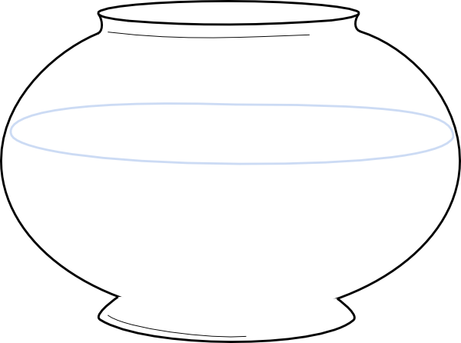
Category | 1 | 2 | 3 | 4 | 5 | 6 | 7 | 8 | 9 | 10
Sea Creatures – Pictograph

Category | 1 | 2 | 3 | 4 | 5 | 6 | 7 | 8 | 9 | 10
Sea Creatures – Bar Graph
Sea Creatures | Tallys | Total

Tally Graph

How many __________? How many sea creatures all together?

How many __________? _______ _______ _______ = ________

How many __________? Compare two sea creatures.

There are ______ more than .
Most =

_______ _______ = _______
Least =

Which type of graph did you choose to show your data and why?

