Life as a Runaway Slave
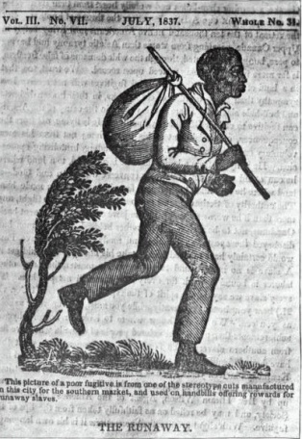
Task: Students will work as a runaway slave in America. Using the web simulation, Flight to Freedom http://ssad.bowdoin.edu:9780/projects/flighttofreedom/intro.shtml, each student will play through twice before answering a set of questions. After the questions have been answered, the student will use Microsoft Publisher or Word to make a scrapbook or journal of their journey. The scrapbook or journal of their journey will contain at least seven images, a summary of their journey in text, their name in the simulation and a synopsis in first person of the experience of being a human being on the run from slave catchers during antebellum times. The scrapbook or journal of their journey will be from the perspective of a slave living during the antebellum times in first person.
Step 1 – Students will work individually as a runaway slave in America and complete the web simulation, Flight to Freedom http://ssad.bowdoin. edu:9780/projects/flighttofreedom/intro.shtml. Provide students with access to the web address. Once they launch the website instruct them to select “hardest” for difficulty level.
Step 2 – Students must play through twice and must document their journey and answer the reflection questions provided by the teacher (see below). Select summary to find out your health status, money and number of family you rescued.
Step 3 – Once finished, students will create their own scrapbook or journal of their journey. The scrapbook should include the following:
- at least seven images
- a summary of their journey in text
- their name in the simulation and a synopsis in first person of the experience of being on the run from slave catchers during Antebellum times
Step 4 – The students will use their questions from their journey on the Flight to Freedom simulation to create a scrapbook or journal. If necessary show students examples of scrapbook pages that have journaling on them. The students should use Microsoft Publisher to create their book. There is an option to make a side fold booklet, which will print two pages/one sheet of copy paper. Open Publisher, find the A4 Booklet option (5.8 X 8.2). They should enter their text first.
Step 5- The students should look for images to use in their scrapbook or journal that symbolizes their journey to freedom.
Step 6 – All students will then turn in their final product in their home drive folder or place in the teacher’s hand-in folder on the server. Students will also provide the teacher with a hard copy of any works cited page for the new information or pictures they gathered for the poster.

Step 7 – Students will share their scrapbook or journal in front of the class in a museum setting.

Life as a Runaway Slave Rubric
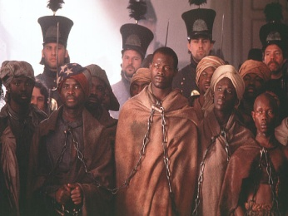

Grading Points:
0=Student is missing the assignment
1=Instructions not followed or very poor quality work
or missing a portion of the assignment
2=Instructions followed with below average (Very little visuals or quotes/facts)
3=Instructions followed with average work (Neat with all requirements met but needed more depth or visuals)
4=Instructions followed with above average work (Neat with all the requirements met)
5=Instructions followed with outstanding work (Neat with all the requirements met, as well as additional material and content that makes the project exceptional)

Seven images that represent the journey

1 2 3 4 5 (x2) ______

The presentation was organized and easy to understand

1 2 3 4 5 ______

Summary of their journey

1 2 3 4 5 (x2) ______

Grammar

1 2 3 4 5 _______

Overall Points ____________ out of 30

Comments: _____________________________________________
______________________________________________________

